**Lesson 4 APP3**

**Container Deployment Using Docker Swarm**

Setting up a Docker instance

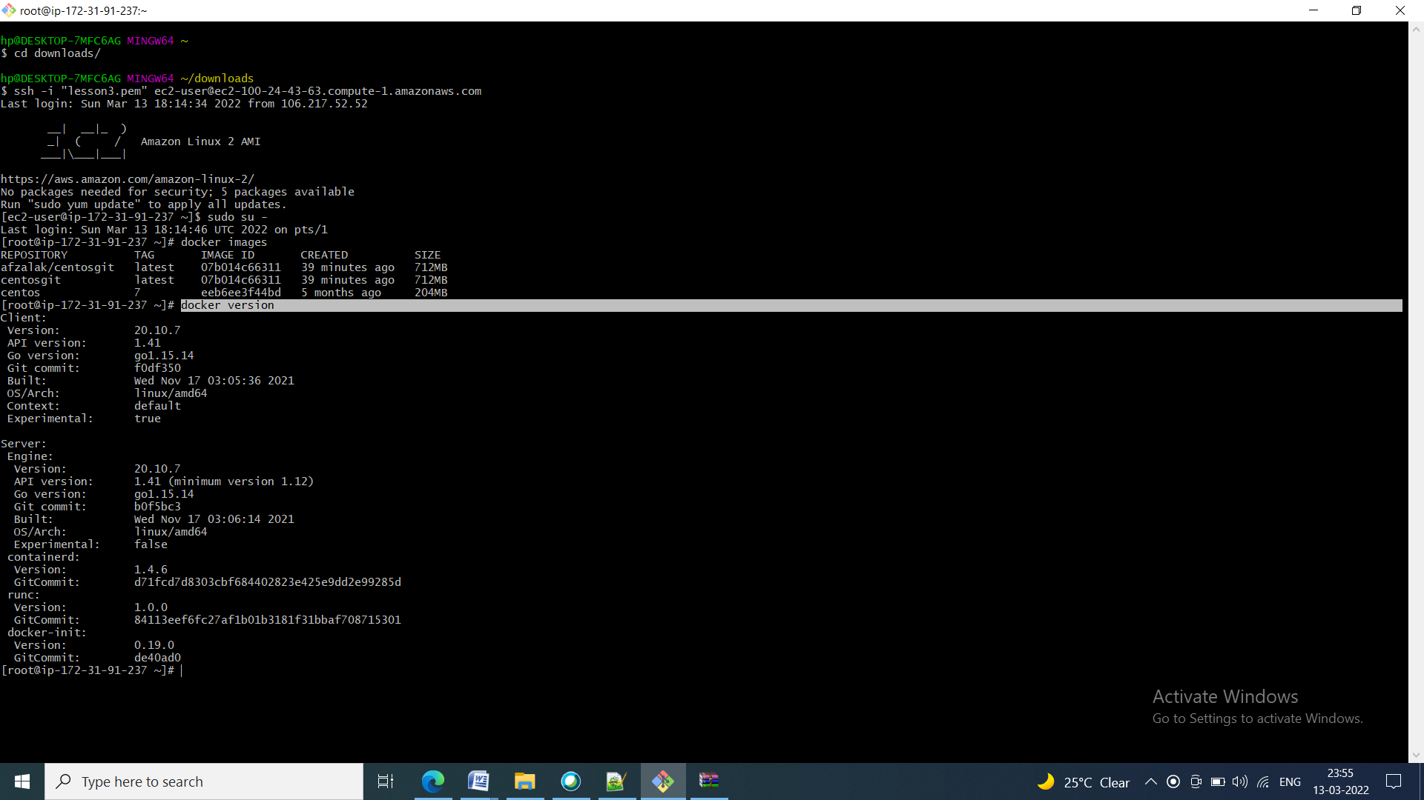

* Once the image is built, check if it is built properly or not. You can see a Docker image entry using Docker images command

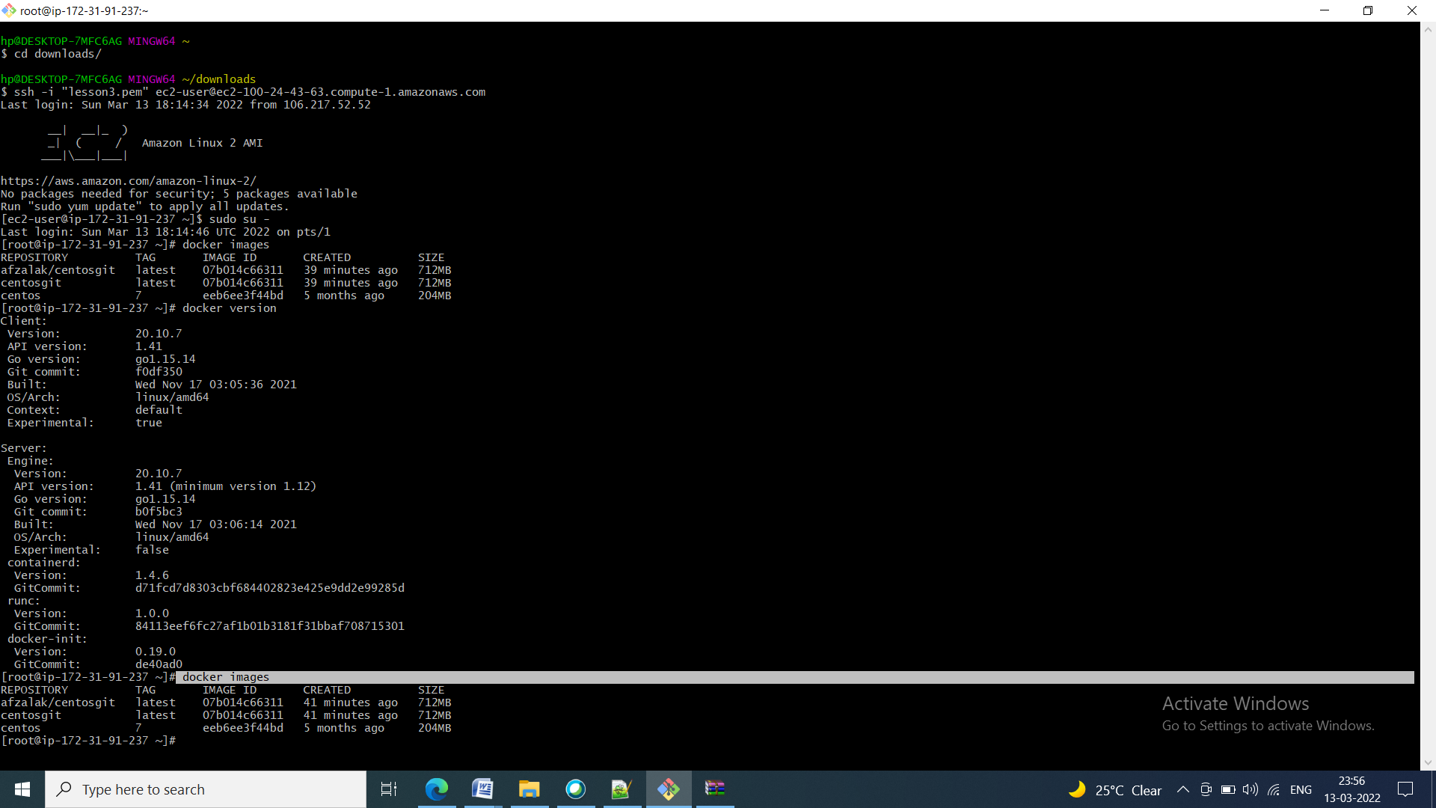

Initializing a Docker swarm cluster and deploying a container to the cluster

* First, we need to initialize Docker swarm using the set of commands given below:

**docker swarm init**

**docker node ls**

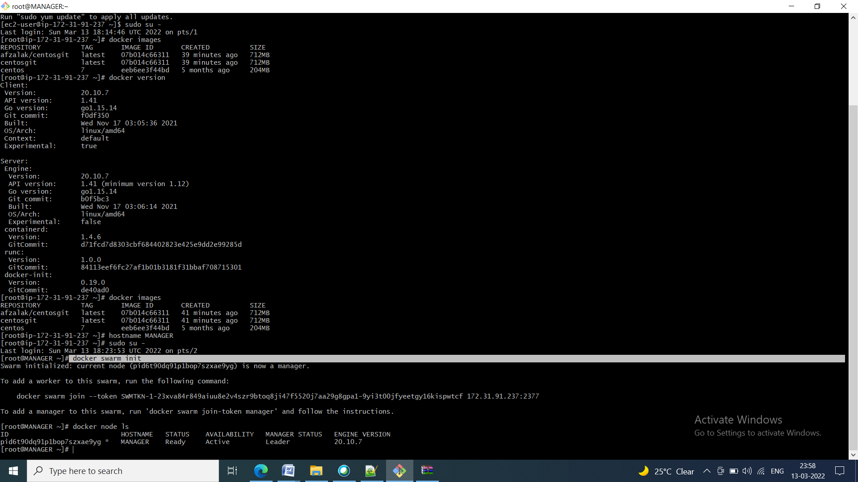

* Once the node is configured, deploy the custom Docker image on the Docker swarm cluster following the process shown below

**docker service create --name mysvc -p 8282:80 --replicas 3 httpd**

**docker service ls**

